Follow the steps to create a local yum repo.

1. Go to /etc/yum.repos.d and check the config file present in this directory
   1. vi centos.repo and observe.

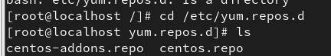

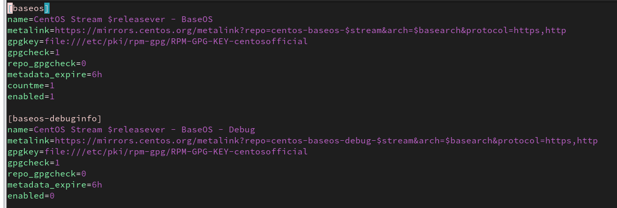

1. Attach the CentOS stream 9 iso file to the system
   1. VM→VM Settings →CD/DVD →use iso image →browse and attach iso file

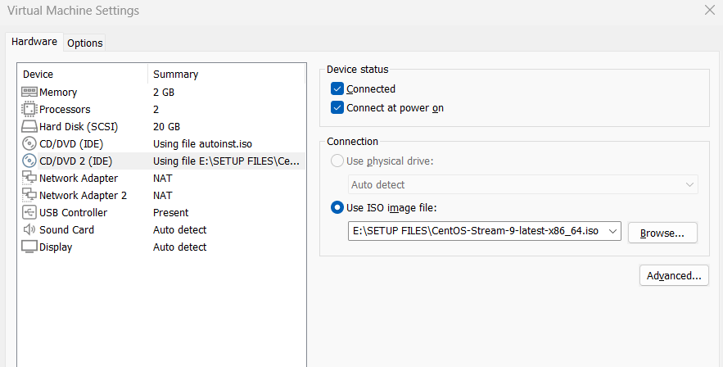

1. Confirm iso is in the system
   1. df -h

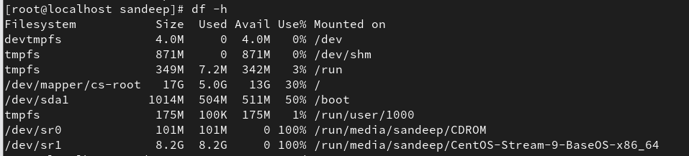

* 1. ls -ld /dev/sr0

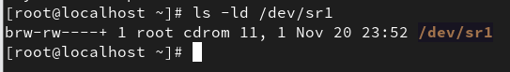

* 1. ls -ld /dev/cdrom

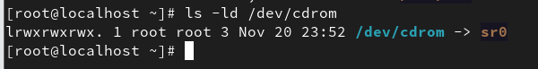

1. Create a mount point for the iso. **
   1. mkdir /iso



1. Mount the iso **
   1. mount /dev/sr0 /iso 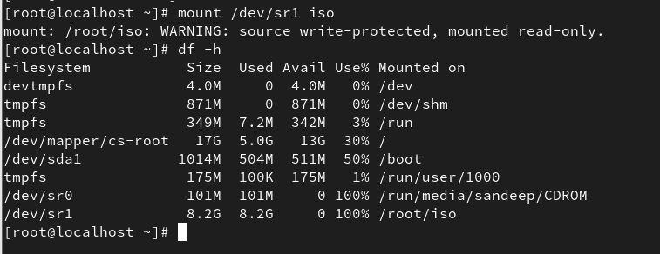
2. Verify the packages files **
   1. cd /iso/AppStream/Packages and ls

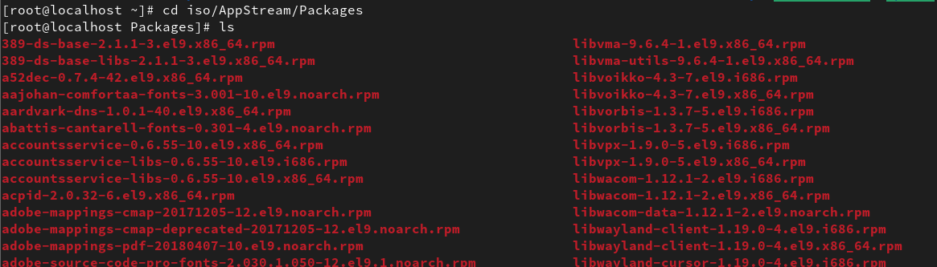

* 1. cd /iso/BaseOS/Packages and ls

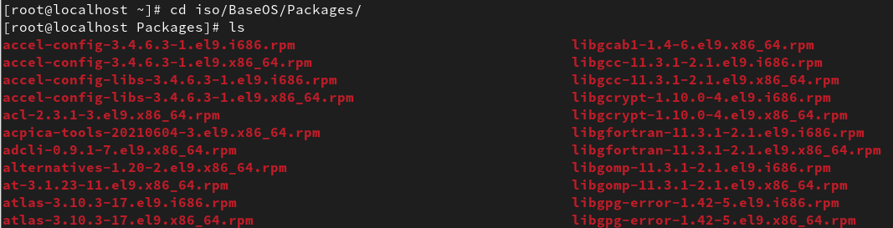

1. Create a directory
   1. mkdir /localrepo/AppStream
   2. mkdir /localrepo/BaseOS

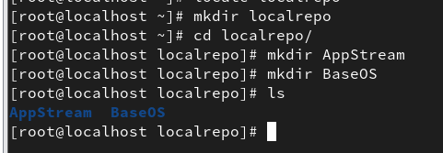

1. Copy the .rpm packages from iso folder
   1. cd /iso
   2. cp -rv AppStream/Packages /localrepo/AppStream/

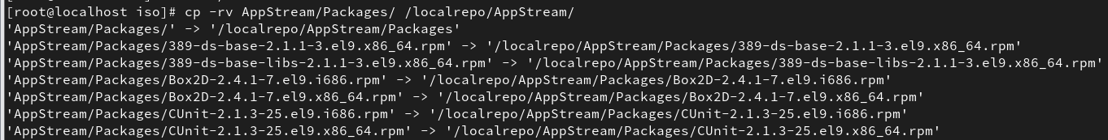

* 1. cp -rv BaseOS/Packages /localrepo/BaseOS/

1. Install createrepo_c package to get createrepo_c command.
   1. yum install createrepo_c

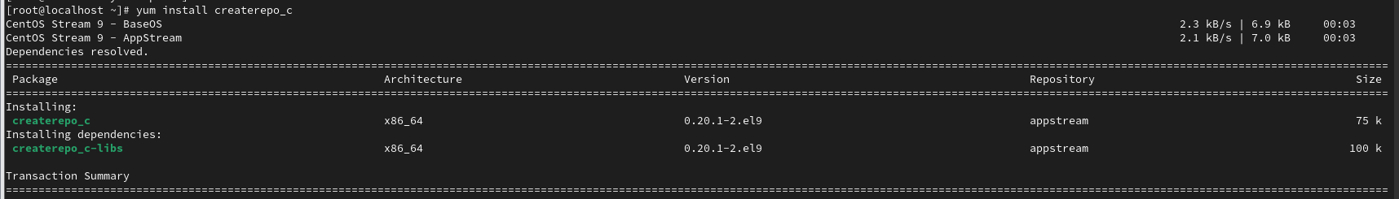

1. Now create the local repository using createrepo_c cmd
   1. createrepo -v /var/ftp/pub/BaseOS/

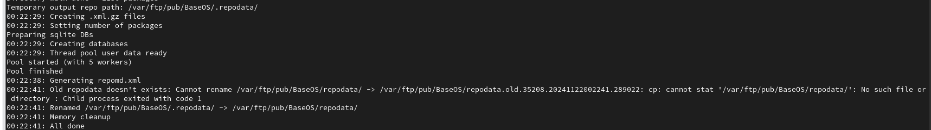

* 1. createrepo -v /var/ftp/pub/AppStream/

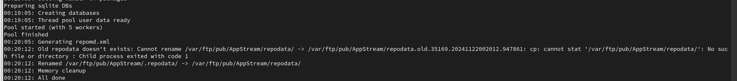

1. Create the repository configuration file in /etc/yum.repos.d
   1. make sure it has .repo extension
   2. vi local.repo – copy the below lines

[Localrepo_BaseOS] name=Localrepo_BaseOS

baseurl=file:///localrepo/BaseOS/Packages enabled=1 gpgcheck=0 [Localrepo_AppStream] name=Localrepo_AppStream

baseurl=file:///localrepo/AppStream/Packages enabled=1 gpgcheck=0

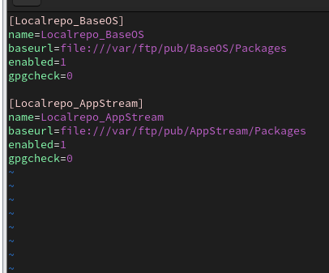

* 1. save and exit
  2. make sure yum.repos.d has only local.repo file

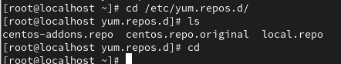

1. check yum repo
   1. yum repolist

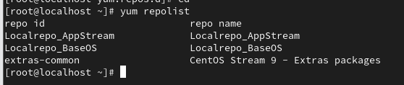

1. yum install httpd

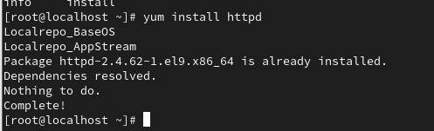

1. yum install mysql

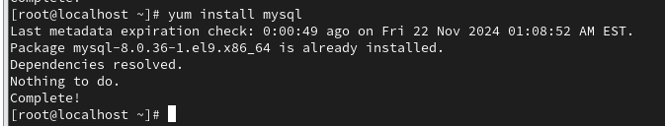

1. yum install nfs-utils

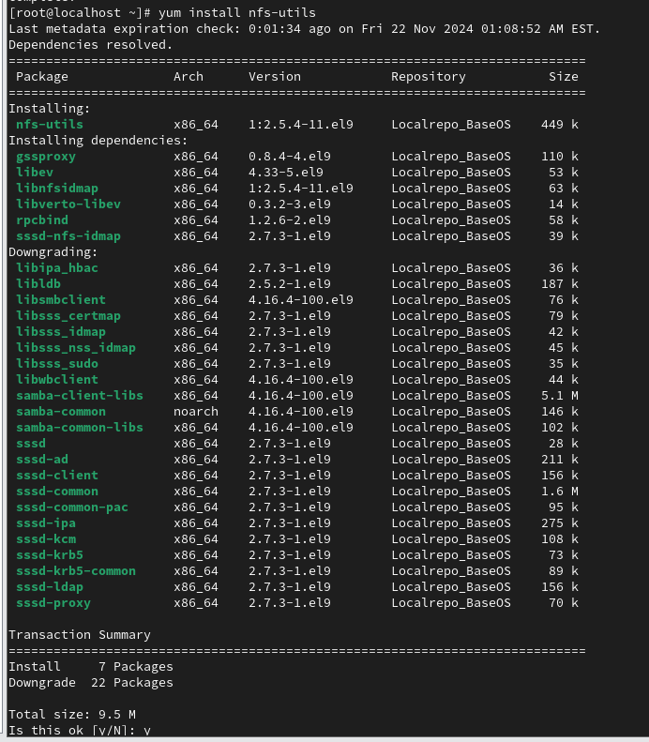

**Steps 4, 5and 6 are optional .If you do not create a mount point for iso.

Instead of Step 8 do the following -

Copy the Packages from

1. cd /run/media/username/ CentOS-Stream-9-BaseOS-x86_64
2. cp -rv AppStream/Packages /localrepo/AppStream/
3. cp -rv BaseOS/Packages /localrepo/BaseOS/ and complete the other steps.